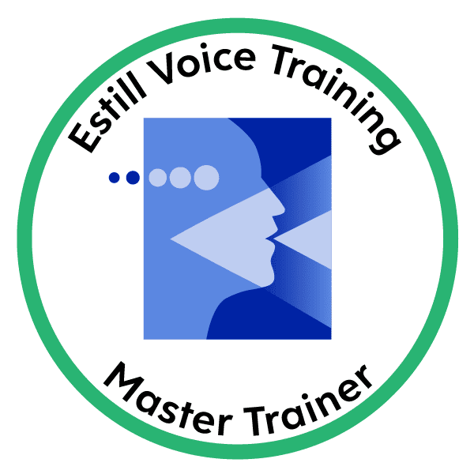LORRAINE MAHONEY Estill Master Trainer, CT ABRSM, ATCL
Tel: 07730 254122
Vocal & Performance Coach
Singing Lessons

January 2025 Registration Form Blended - Including ONLINE LESSONS

Please complete & email to professionalvoiceusers101@gmail.com

Pupil Details
Surname: |  |  | Forenames:
Address & Post Code:

Which school does your child attended?
Telephone Number (if over 18yrs):
Date of Birth: |  |  |  | Age at registration:

PARENT OR GUARDIAN (if under 18yrs)
Surname: |  | Forename  Mr/Mrs/Ms/Miss/(Other……..)  (delete as appropriate)
Daytime Telephone Number:
Evening Telephone Number:
Mobile Telephone Number:
Email Address:

Alternative Emergency Contact Details (Friend or Relative)
Name: | Relationship to Pupil:
Telephone Number:

Pupil Medical Conditions
Are there any medical conditions, allergies or other facts that Lorraine should be aware of? (If yes, Please give details)

Details of Any Previous Voice Training Experience
For example examinations or concerts etc in singing or performing arts:

Parental Agreement:
In Venue: Lessons will be held in Lorraine’s studio in Semington. Online lessons are conducted via Zoom. Lessons will be recorded as part of our safeguarding procedures. By attending online lessons, I (my child) participate at my own risk. By completing this form and by attending online lessons, I agree to these requirements. Pupil clothing – appropriate day time clothing to be worn – as in formal face to face lessons. Tshirt and joggies are fine. No skirts. An adult must be present at home and the lesson should take place in a family room with the door open. Pupils should not be taking lessons in bedrooms.
I agree with the above and will update Lorraine with any changes to the above in writing.

Electronically Signed (Parent/Guardian) …………………………………………………….……………….. Date …………………………………………………...

